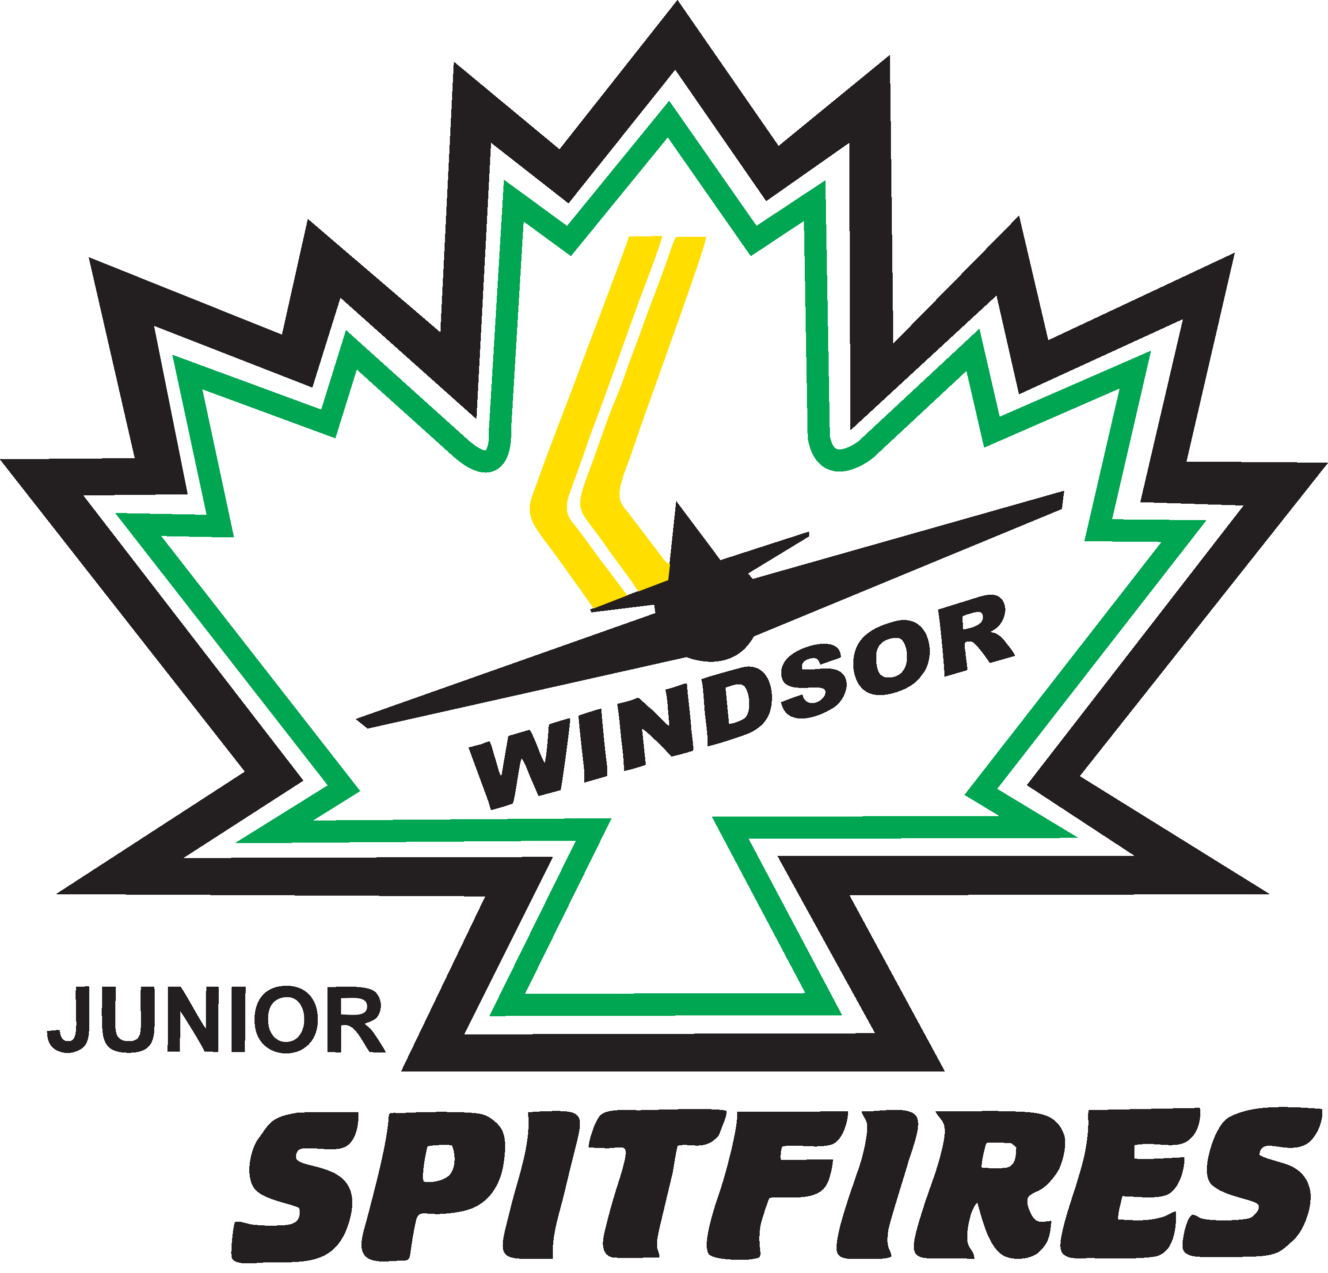
Windsor Minor Hockey Association
Sponsorship Application
P.O. Box Station “A”
Windsor, ON N9A 6N4
www.wmha.net

2021-2022 Sponsorship Application

The Windsor Minor Hockey Association would like to invite you to be a sponsor for the upcoming hockey season. Each year the WMHA depends on kind sponsors, such as yourself, to help cover expenses such as our operating costs, jersey costs, and most importantly to keep our ice costs down. As we are a non-profit organization, we count on the compassion of businesses in our area to help with these expenses. Being a WMHA sponsor also has many advantages to you, the sponsor, such as:

- Having your company’s name on the back of a team jersey (team sponsor option only)
- Your company’s business information is advertised on our website
- Promotional materials posted on our website, and emailed to our members upon your request
- Preferred choice to WMHA business
- Networking opportunities to all of our members
- Helping a community driven organization provide hockey in Windsor

The success of our program, and these kids playing hockey depends on community support, especially in the form of a sponsorship. It is truly mutually beneficial, and our past sponsors can attest to that. If you would like to be a sponsor this season, please fill out the information below. Once complete you may mail it back with a cheque, or email the form to Val Coletti at valcoletti@hotmail.com and we will arrange to pick up the cheque in person.
Windsor Minor Hockey Association
Sponsorship Application
P.O. Box Station “A”
Windsor, ON N9A 6N4
www.wmha.net

2021-2022 Sponsorship Application

Business Name:
Address: Postal Code:
Contact Person: Phone:
E-mail:
Company Website:
Team sponsorship are $500 per house league team, or $1000 per travel team (home and away jerseys). Team sponsors are on a first come first serve basis, and we will do our best to match your sponsorship to the team of your choosing. If we can’t get your Company on the back of a jersey, you can still choose to be a major sponsor which would get you a banner at the top of our page.
Divisional Sponsor Request:
☐ U9 ☐ U10 ☐ U11 ☐ U12 ☐ U13 ☐U14 ☐U15 ☐U16 ☐U17 ☐U19
Do you have a child playing on a team that you would like this sponsorship directed at?
☐ YES ☐ NO
If “yes”, Chid’s Name:
Jersey Colour Requested:

